- Purpose
  - The purpose of this document is to describe the procedure for assembling an Optima Propane Burnisher with the dust control option.
- Scope
  - This SOP applies to all equipment assembly team members. The process applies to the following machines:
E012850EQM0600BE1200 – 27” Optima XR w/ Dust Control
E012852EQM0600BE1200 – 27” Optima XR w/ Dust Control without tank
E012860EQM0600BE1200 – 27” Optima XR w/ Clutch & Dust Control
E012862EQM0600BE1200 – 27” Optima XR w/ Clutch & Dust Control without tank
E012865EQM0600BE1200 – 27” Optima XR w/ Emissions & Dust Control
E012867EQM0600BE1200 – 27” Optima XR w/ Emissions & Dust Control without tank
E012875EQM0600BE1200 – 27” Optima XR w/ Emissions, Clutch, & Dust Control
E012877EQM0600BE1200 – 27” Optima XR w/ Emissions, Clutch, & Dust Control without tank
- Responsibilities
  - The operations manager/supervisor is responsible for enforcing this SOP.
- Materials
  - The proper materials needed for this process are listed on the sub-assembly work order.
  - Hand/Power Tools
- Definitions

- Procedure
  - Start by assembling an Optima Propane Burnisher Deck with Dust Control per SOP EQ 080.
  - Assemble the motor per SOP EQ 027.
  - The oil drain on the motor will need to be pointed slightly upwards as shown. Place the engine onto the deck with the output shaft going through the large hole in the deck.

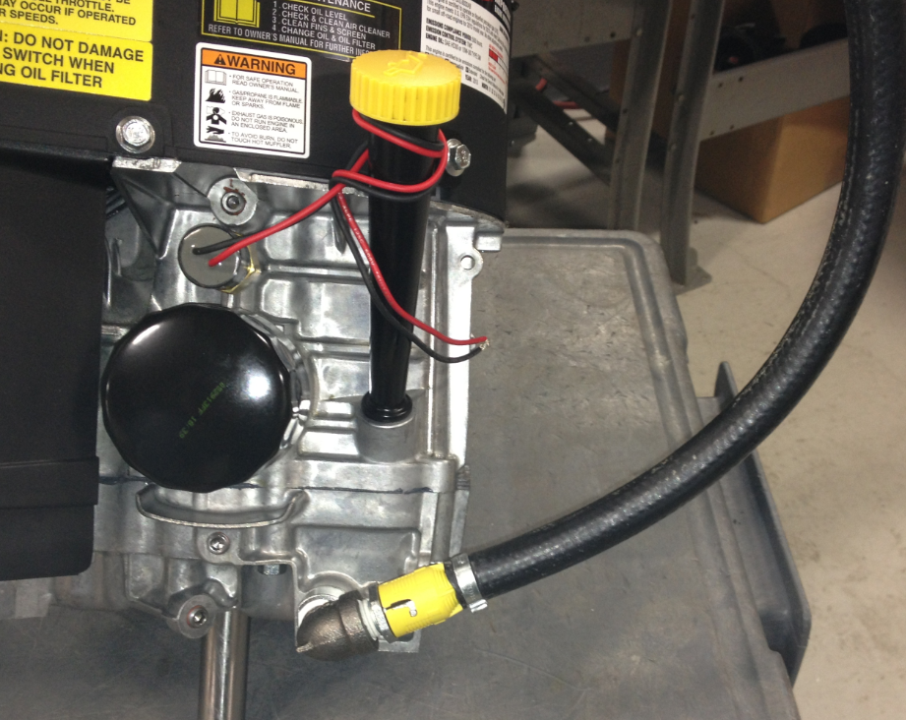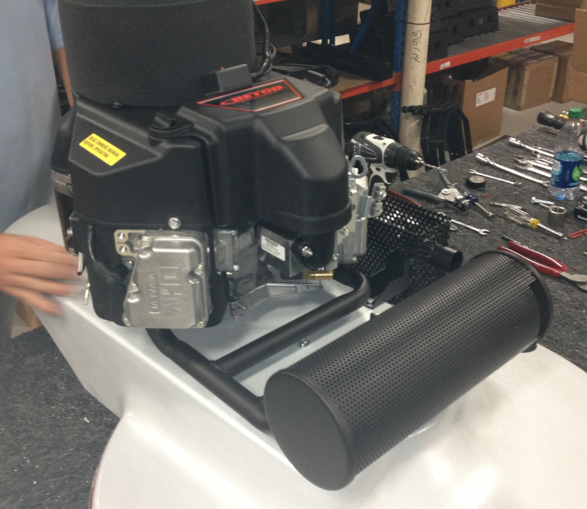

  - Bolt the engine to the deck from the bottom using 4 bolts (87644) and 4 lock washers (81066).
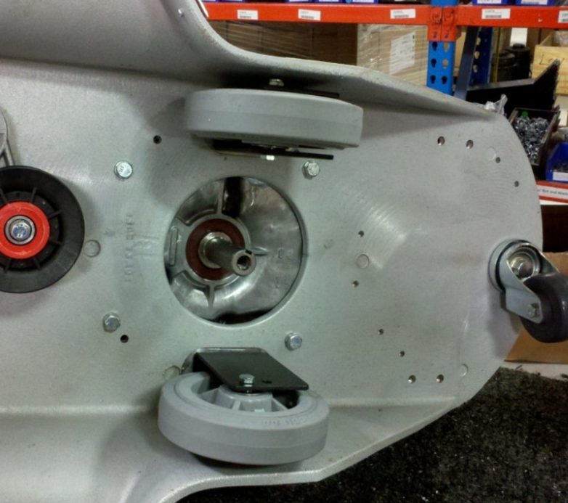

  - If the machine is to be equipped with a clutch, proceed to step 5.07. If the machine will not have a clutch, advance to step 5.14.
  - Get a centrifugal clutch (89768) and remove the set screw from the collar on it.

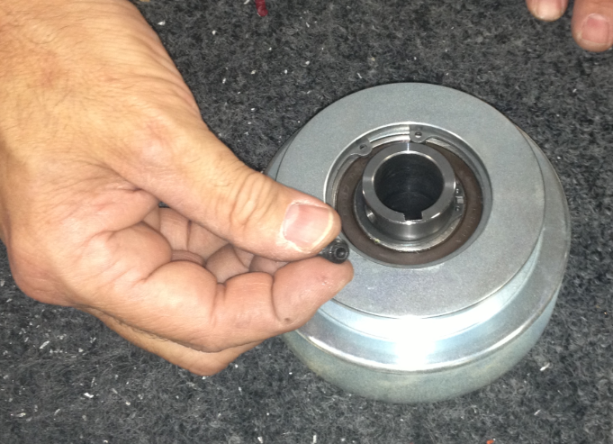

  - Place the top clutch spacer (86122) over the end of the motor shaft as shown.

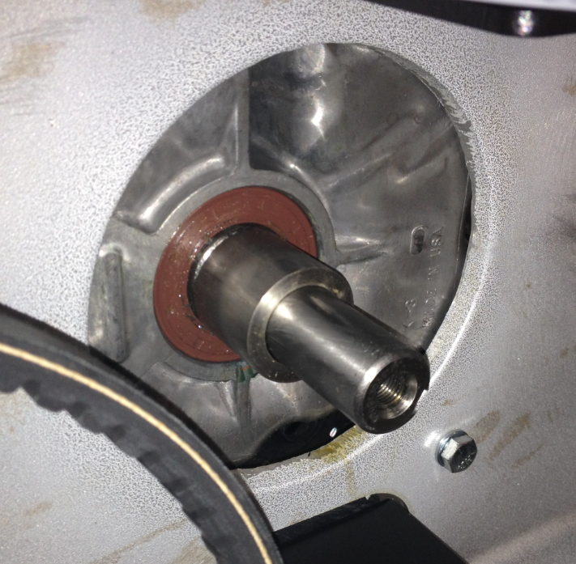
  - Place the clutch onto the shaft in the orientation shown.

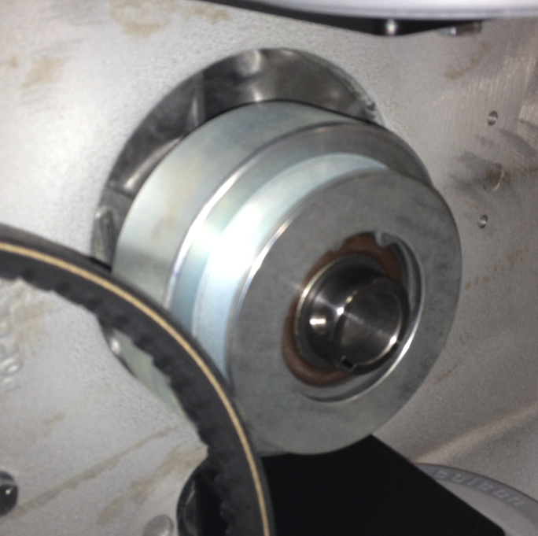

  - Align the keyways on the motor shaft and the clutch. Once this is done, slide a key (11289) into the keyway.

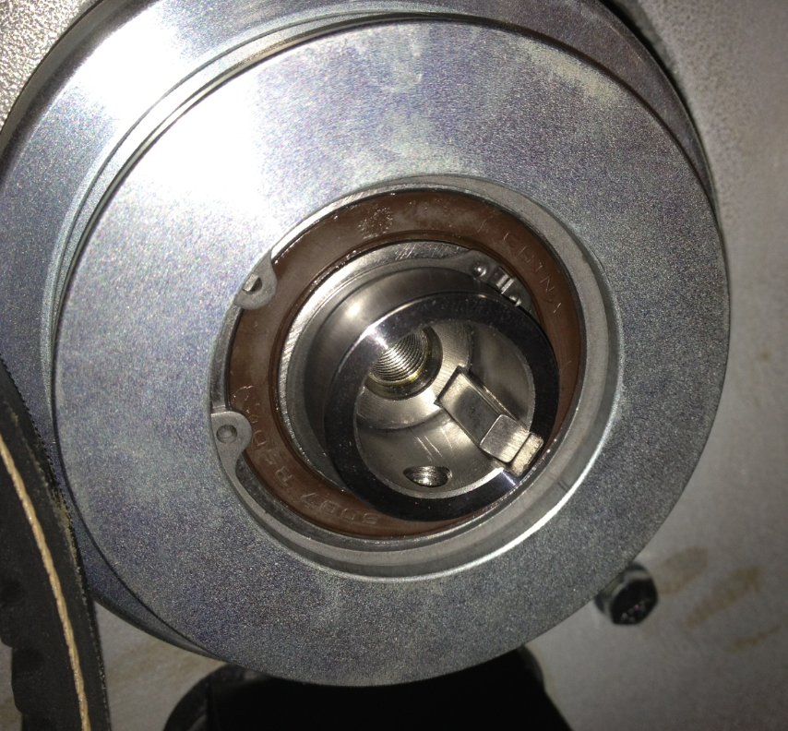

  - Place the bottom clutch spacer (86229) into the location shown.

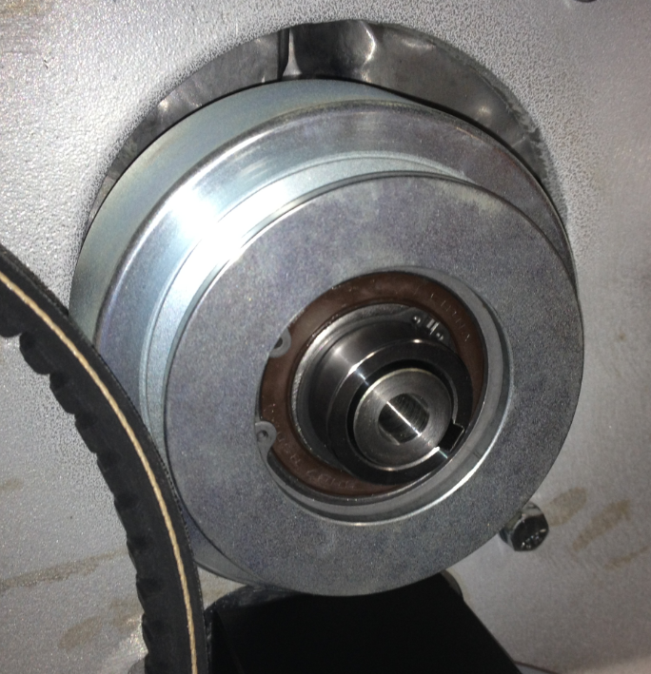

  - Fasten the clutch onto the engine shaft using a bolt (10598), a lock washer (10117), a flat washer (12447), and another flat washer (11501). Put some blue Loctite onto the bolt threads before installing.

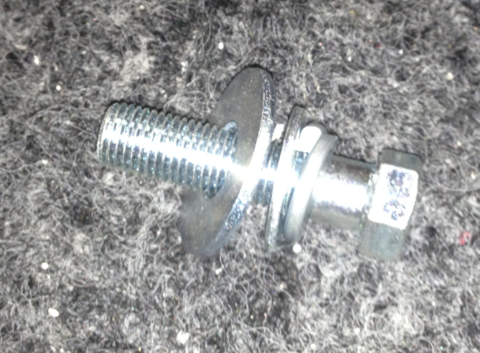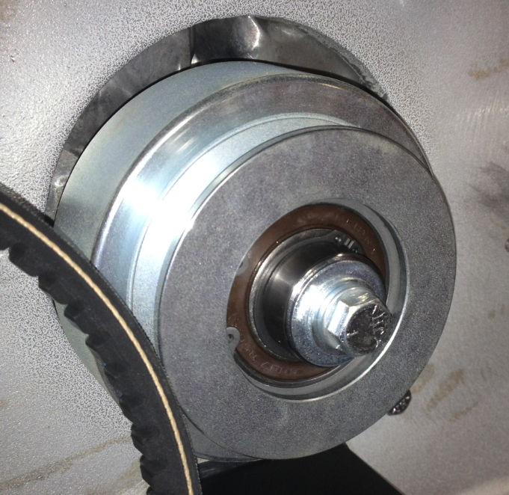

  - Proceed to step 5.15. NOTE: Some of the photos after this may show a standard pulley or a clutch on the motor shaft.
  - Get a drive pulley that was assembled per SOP EQ 074. Slide the pulley assembly onto the motor shaft in the orientation shown. Be sure to line the keyway up. Install the key (11289). You may need to tap it with a hammer to get it all the way in.
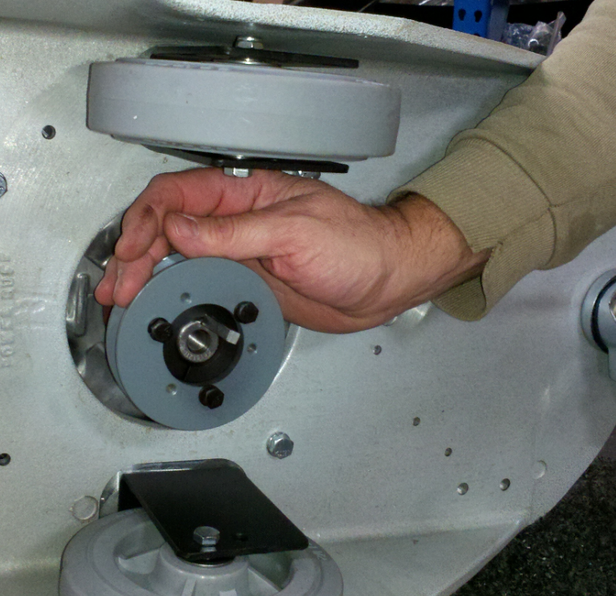
Pulley
Key
Bushing

  - Install the belt around the pulleys. This step may be difficult. You may need to spin one of the pulleys to get the belt stretched around and properly seated.

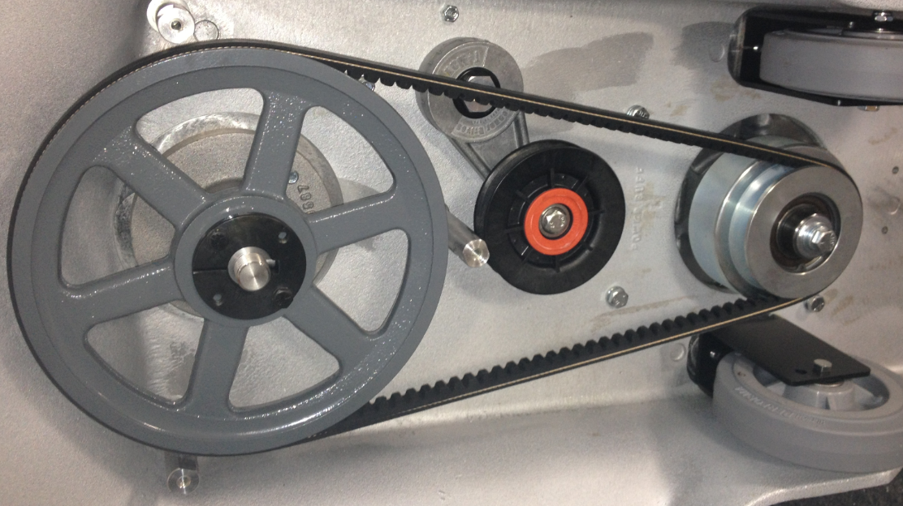

  - Tighten the screws on the bushing. Do not tighten each one individually all the way. Alternate back and forth tightening each one little by little. This will ensure that the assembly does not bind. Verify the the pulley is centered on the belt so that it does not cause any uneven wear. Loosen the screws and move the pulley if needed. Once that is complete, tighten the set screw that is located on the collar of the bushing.
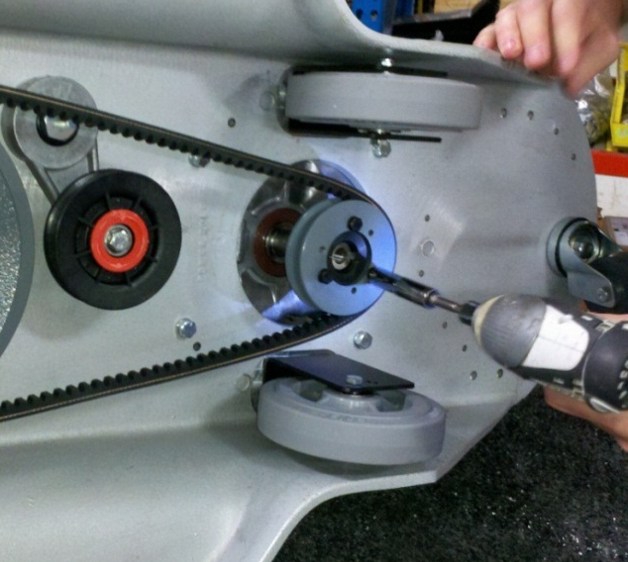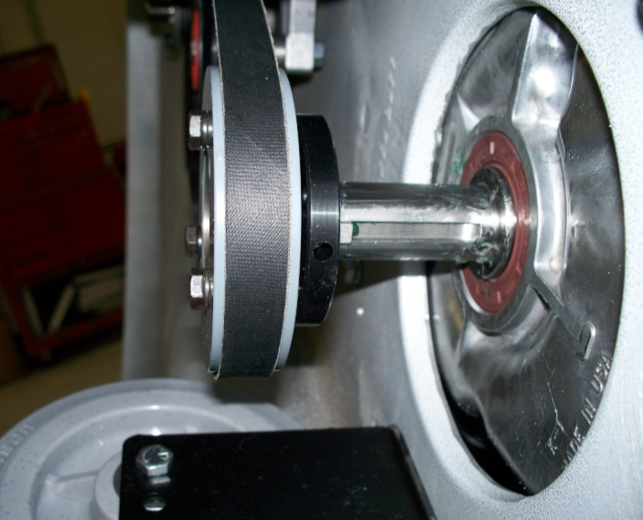
Set screw location

  - Using a long handled socket wrench, tighten the tensioner pulley. Use the socket wrench to rotate the pulley until the desired amount of tension is reached. Use the photo below as a reference. On the top side of the deck, tighten the bolt that was put into place finger tight earlier.

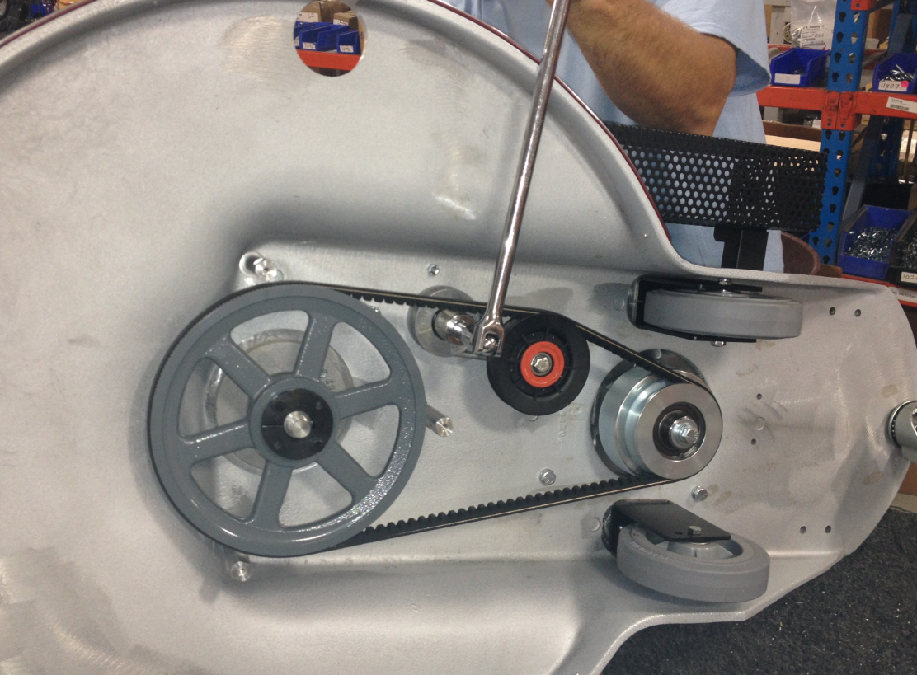

  - Place 2 washers (11135) over the threads of the center pulley shaft. This will shim the pad driver to the correct location.

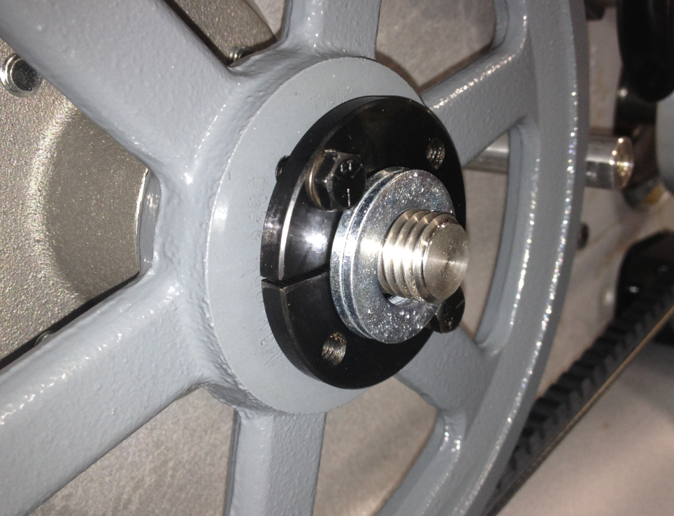

  - Assemble a propane dust control shroud. For assembly instructions, refer to SOP EQ 053.

  - Fasten the shroud to the standoffs using 3 screws (81064), 3 lock washers (81078), and 3 flat washers (81713). Line the port on the shroud up with the hole in the deck.

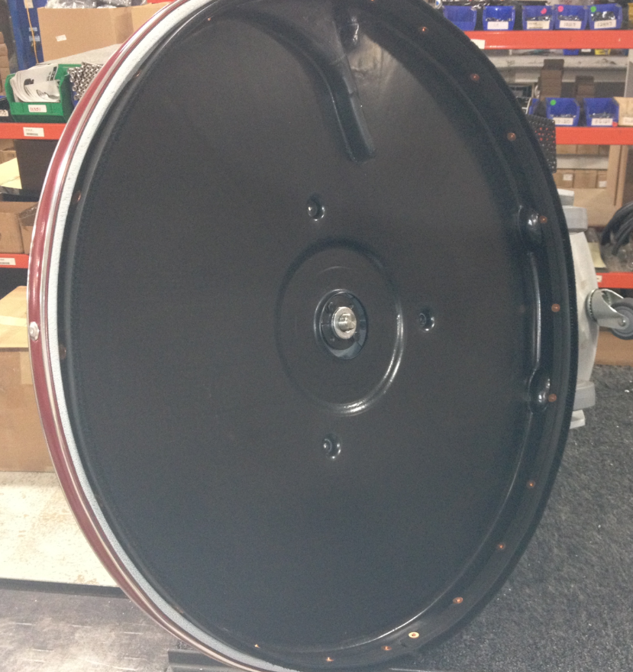

  - Assemble a 27” pad driver using the instructions in SOP EQ 024. Put some anti-seize compound on the threads of the pad driver. Thread the pad driver onto the spindle. Keep in mind that the spindle has left handed threads.

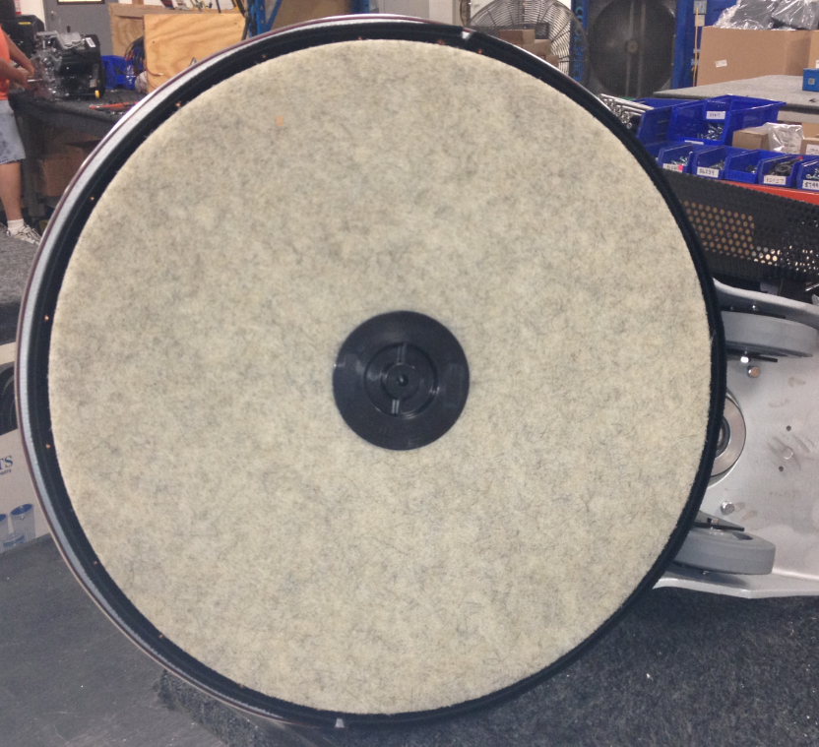
  - Place the machine back onto its wheels.
  - Connect the port on the shroud to the port on the filter bag weldment using a hose (89608).

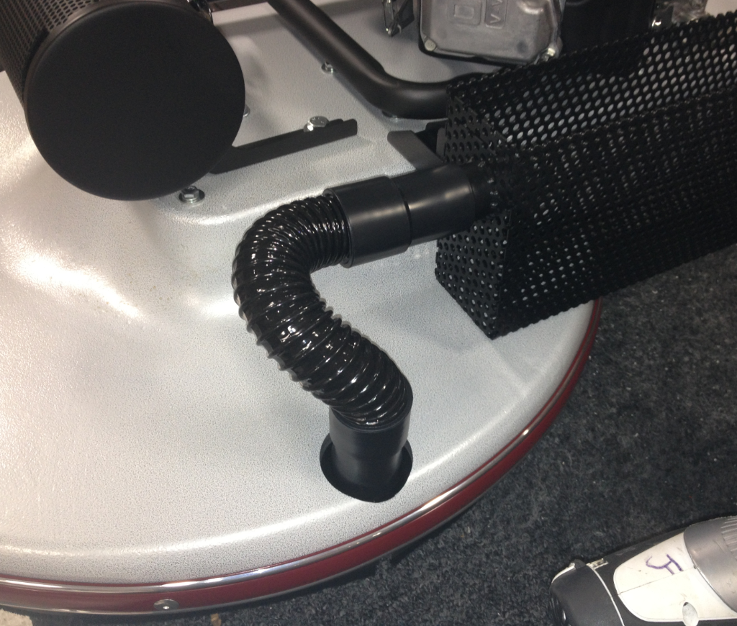

  - Place a 3” piece of edging (89604) onto the front and back edges of the filter bag weldment.

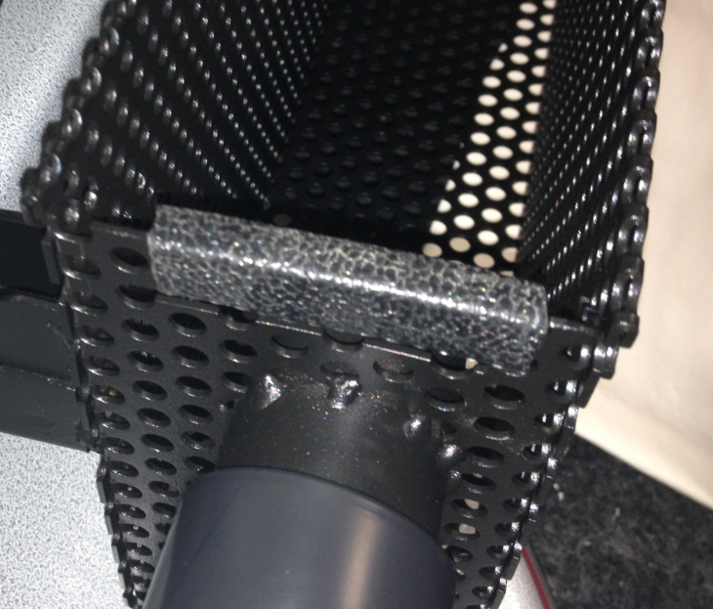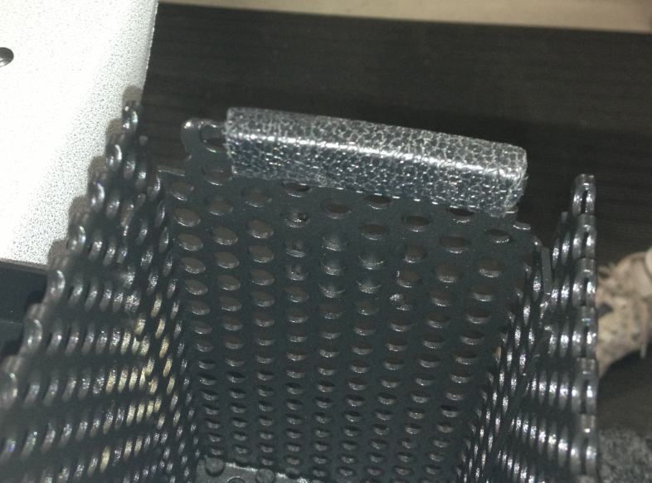

  - Put a filter bag into the weldment. Push the opening in the bag onto the port.

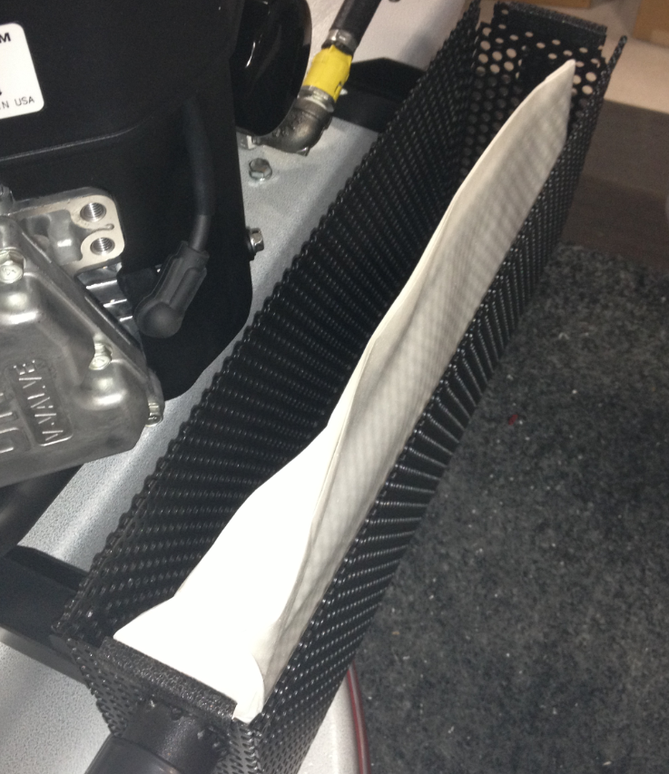
  - Take a draw latch (89592) and keep the latch, the cotter pin, the washer, and the pin. Discard the remaining components.

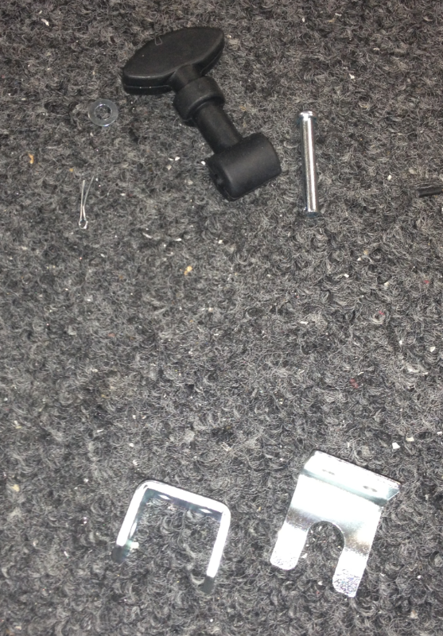
Throw away

  - Install the latch onto the back of the weldment using the components that were provided with it. Bend the legs on the pin to keep it from falling out.

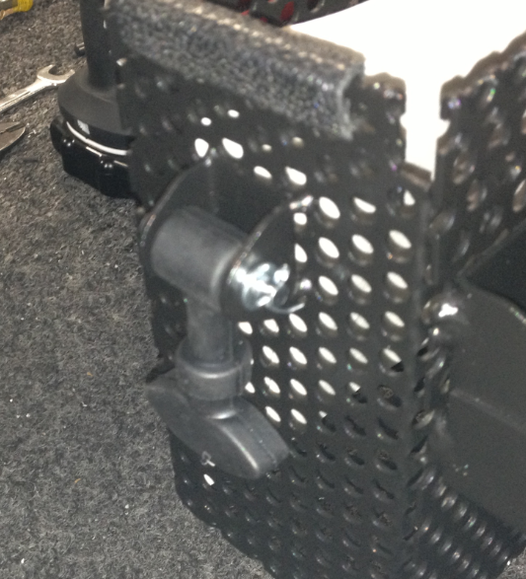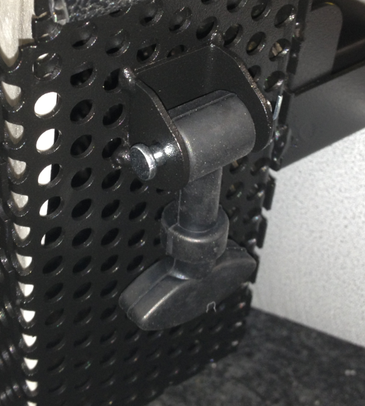

  - Put a bag holder cover into place. There is a lip in the front that interlocks with the weldment.

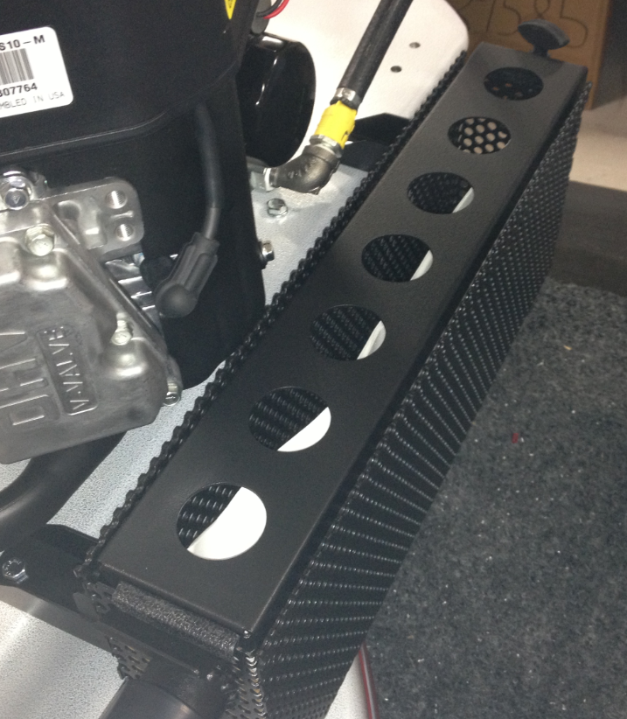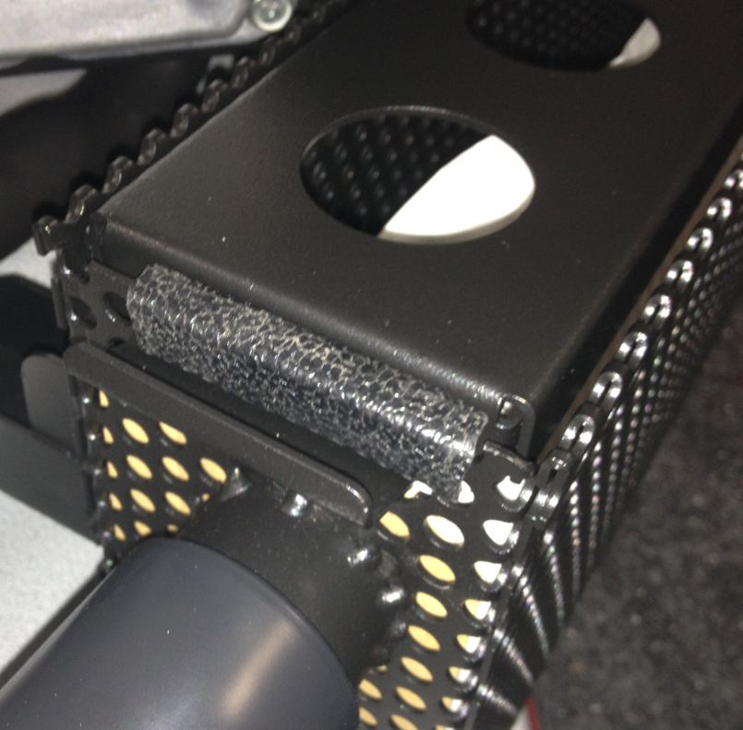
  - Latch the cover into place in the back.

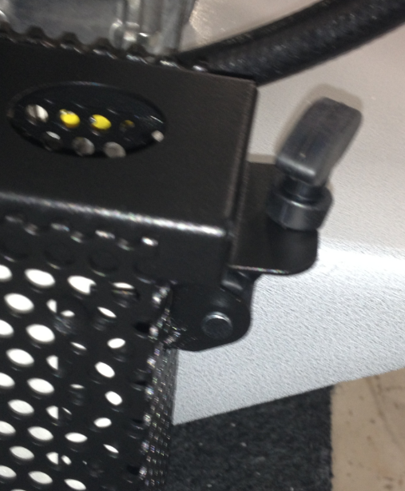

  - Continue with assembly of the rest of the machine per the appropriate SOP starting at the solenoid installation.
- References (optional section as needed)

- Training Guide

Functional Training Groups Requiring Training
Equipment Assembly Group

- SOP Change Control

Date of Change | Reason for Change
11/19/2013 | This is the first version of the S.O.P. hence there are no revisions to this document.
1/12/2018 | Added Responsibilities section
5/4/2018 | Updated for the Optima XR upgrade
3/21/2025 | Removed work center notes

Approvals

Submitter/Author Approval:__________________________________ Date:______________________

Management Approval:______________________________________ Date:______________________

QAU Approval:_____________________________________________ Date:______________________

